SQL Server Integration Services

# Module 01: creating SSSIS Catalog DB

1. Launch SQL Server Management Studio (SSMS), under start menu look for Visual Studio 2017 (SSDT).
2. Right-click on the Integration Services Catalogs folder and select **Create Catalog**.  
   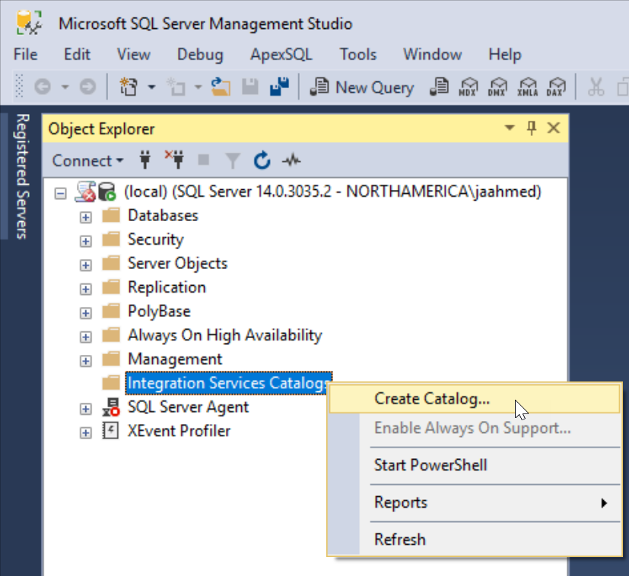
3. In Create Catalog dialog box select “Enable automatic execution of Integration Services stored procedure at SQL Server Startup” and enter the Password to protect the encryption key and click OK.

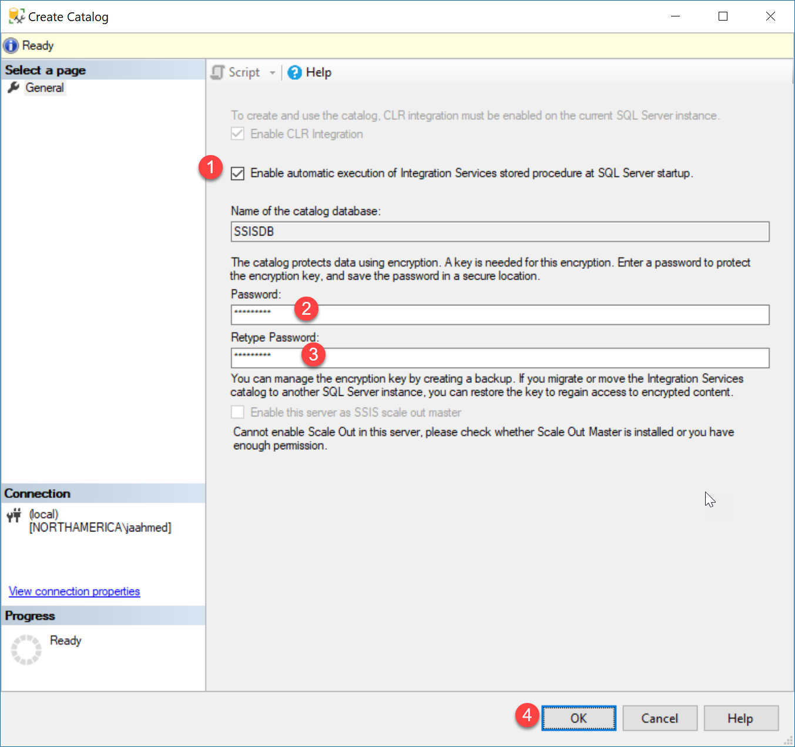

|  |
| --- |
| **Note:**  *Enable automatic execution of Integration Services stored procedure at SQL Server Startup*  Setting will create [master].[dbo].[sp_ssis_startup] procedure with ExecIsStartup property set to true. This procedure will in turn call [SSISDB].[catalog].[startup] procedure.  USE master;  SELECT name,create_date,modify_date  FROM sys.procedures  WHERE OBJECTPROPERTY(OBJECT_ID, 'ExecIsStartup') = 1  exec sp_helptext 'dbo.sp_ssis_startup'; |

1. After successful creation of the catalog. You will see a new database SSISDB created, a new SQL Job “SSIS Server Maintenance Job” created.

You will also see a new SSISDB item in the Integration Services Catalogs folder. This is simply an SSMS interface to create records in the SSISDB database.

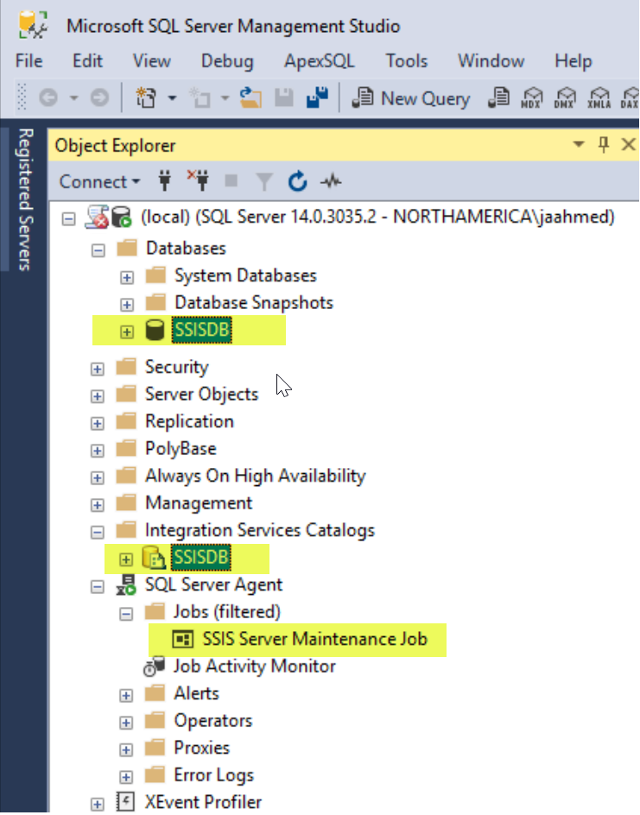

1. Create your first SSIS Catalog folder. Integration Services Catalogs 🡪 SSISDB 🡪 right-click and select create folder.

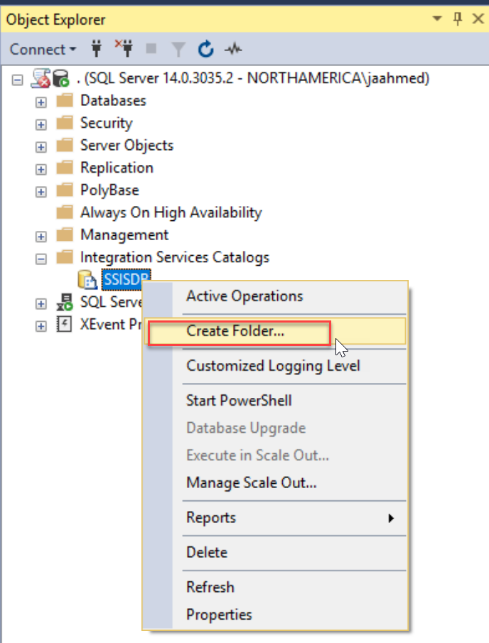

1. On the Create Folder dialog, enter the name name of the folder and click OK.

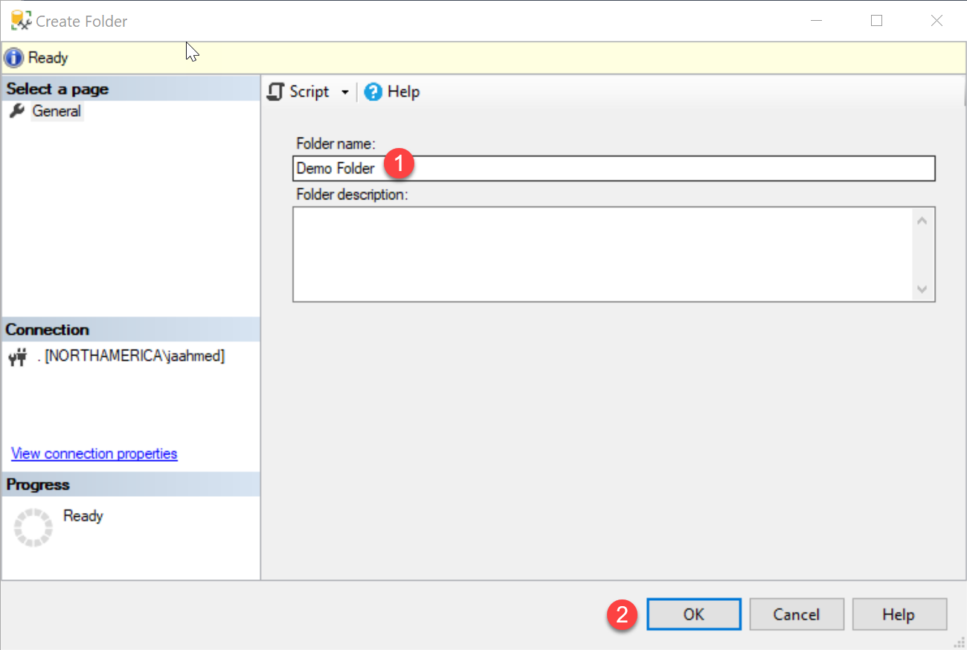

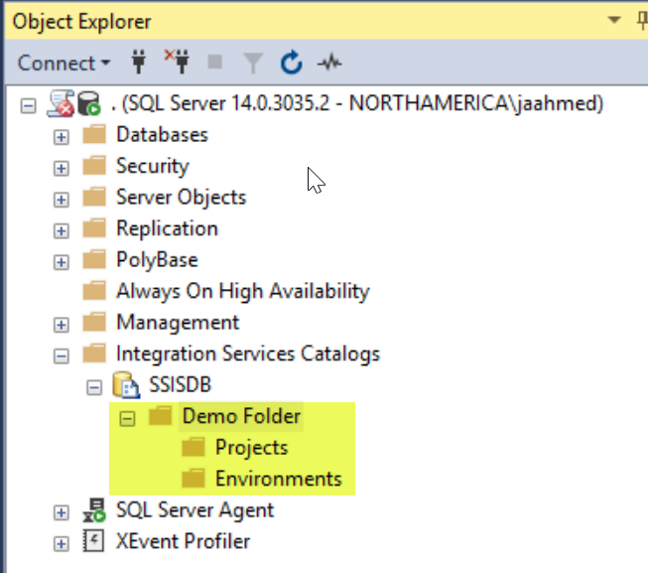

1. Backup the SSISDB Master key, for future Restore purposes. And note down the password used to protect the key. Run the Following Query in SSMS , and store the exported Key in a secure place.

use SSISDB;

backup master key to file = 'c:\temp\SSISDBKey'

encryption by password = 'LS2Setup!'

/*

Restore master key from file = 'c:\temp\SSISDBKey'

Decryption by password = 'LS2Setup!' -- 'Password used to encrypt the master key during SSISDB backup'

Encryption by password = 'LS3Setup!' -- 'New Password'

Force

*/

**Reference:** <https://docs.microsoft.com/en-us/sql/integration-services/backup-restore-and-move-the-ssis-catalog?view=sql-server-2014>